

# 

# Assignment # 03

Submitted to Ms.Humaira batool

Submitted By Ahmad Junaid

Roll No 2462

Subject DBMS-Lab

Department CS

Class BSCS-EVE

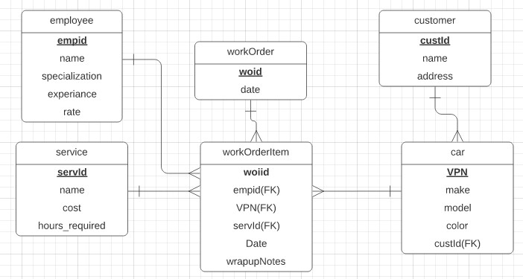

Figure1: ERD of Car AutoMechanics

**Q5: Write SQL for the following queries based on given ERD.**

1. Details of cars owned by “Mehwish Sabih”.
2. Details of customers who own Red cars.
3. Names of employees who have worked on Honda civic.
4. List all appointments of Mr. Rashid’s car(s).
5. List all customers living in F6 and F7. (Note: Address contains complete address of the house)
6. List all jobs carried out by Mr. Shahid (Employee).
7. Name of the most expensive service available.
8. Details of all customers whose name starts with the alphabet ‘A’.
9. Details of all Honda owners with Models between 2000 and 2020.
10. List maximum and minimum salary given to employees.
11. Display name of services that costs maximum.
12. Display name of services that costs minimum.
13. Display all services provided by AutoMechanics in ascending order of cost.
14. Display all services provided by AutoMechanics in descending order of time required.
15. Display number of employees with more than 5 years of experience.
16. Display details of customers with more than two cars.
17. Display total number of Honda civics currently registered with AutoMechanics.
18. Display details of cars that visited AutoMechanics only once.
19. Display details of Mechanics that have not worked on any car yet.
20. Display details of Service(s) not yet availed by any customer.

## **Creating Tables**

**create table employee**( empid number(10) primary key, name varchar2(20), specialization varchar(40), experience varchar2(40), rate number(20)

);

**create table customer**( custId number(10) primary key, name varchar2(30), address varchar2(50)

);

**create table** **service**

(

servId number(20) primary key, name varchar2(20), cost number(20), hours_required number(20)

);

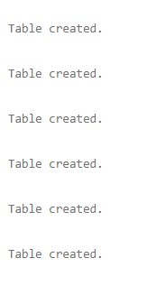

**CREATE TABLE Car**

(

VPN NUMBER(20) PRIMARY KEY, Make VARCHAR2(15), model VARCHAR2(25), color varchar2(25), custId number(10),

FOREIGN KEY(CustId) REFERENCES customer(CustId)

);

**create table work_Order**

(

woiid number(30) primary key, dates varchar2(20)

);

**create table work_Order_Item**

(

woiid number(10) primary key,

empid number(10), FOREIGN KEY(empid) REFERENCES employee(empid), VPN number(20), FOREIGN KEY(VPN) REFERENCES car(VPN), servId number(20), FOREIGN KEY(servId) REFERENCES service(servId), dates varchar2(30), wrapupnotes varchar2(40)

);

## **Insertion**



insert into customer values(1,'Mehwish Sabih','isl'); insert into Car values('83','Toyota','camry','yellow',1);

## 1)

**select cu.custid,cu.name, c.VPN, c.make, c.model, c.color from Car c inner join customer cu on cu.custid=c.custid;**

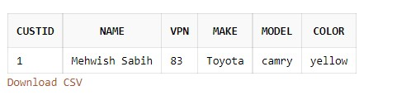

## 2)

**select cu.custId, cu.name, cu.address, c.make, c.color**

**from customer cu, car c where cu.custId=c.custId and color='red';**

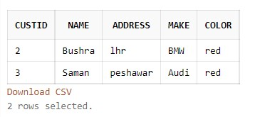

## 3)

**SELECT name ,model**

**FROM Employee e, work_Order_Item w, Car c**

**Where e.empid = w.empid AND w.VPN =c.VPN**

**AND c.model='honda civic'**;

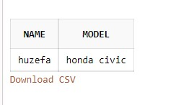

## 4)

**SELECT customer.custId, customer.name, car.VPN, car.custId,**

**workOrderItem.VPN, workOrderItem.woiid, workOrder.woiid, workOrder.date FROM customer, car, workOrderItem, workOrder WHERE customer.custId = car.custId AND customer.name = ‘Mr. Rashid’;**

## 5)

**SELECT custId, name, address FROM customer WHERE address = ‘F6’ OR address = ‘F7’;**

## 6)

**SELECT e.empid, e.name, w.empid, s.servid FROM employee e, workOrderItem w, service s WHERE empid = 201;**

7)

**SELECT MAX(cost), servid, name, AS ‘Expensive Service’ FROM service;**

8)

**SELECT * FROM customer WHERE name LIKE ‘A%’;**

## **9)**

**SELECT customer.custId, customer.name, customer.address, car.custId, car.make, car.model FROM customer, car WHERE car.model BETWEEN 2000 and 2020 AND car.make = ‘Honda’;**

**10)**

**SELECT MAX(rate), MIN(rate) FROM employee;**

**11)**

**SELECT name, MAX(cost) FROM service;**

**12)**

**SELECT name, MIN(cost) FROM service;**

**13)**

**SELECT name FROM service ORDER BY cost;**

**14)**

**SELECT name FROM service ORDER BY hours_required DESC;**

## **15)**

**SELECT empid, name, experience FROM employee WHERE experience > ‘5 years’;**

## **16)**

**SELECT custid, name FROM customer WHERE 2 < (SELECT COUNT(*) FROM car WHERE custid = customer.custid);**

## **17)**

**SELECT car.vpn, car.make, employee.empid, employee.name FROM car, employee WHERE car.make = (SELECT COUNT(make) FROM car WHERE make = ‘Honda’ AND make = employee.emp.name);**

## **18)**

**SELECT * FROM car WHERE 2 > (SELECT servid FROM service WHERE servid = car.VPN);**

## **19)**

**SELECT e.empid, e.name. e.specialization, e.experience, e.rate, w.woiid FROM employee e, workOrderItem w WHERE w.woiid IS NULL;**

## **20)**

**SELECT s.servid, s.name, c.custid FROM service s, car c WHERE c.custid IS NULL;**

END